MCQs

Cambridge IGCSE O/L Units: Databases

Tutorial 6

- What is the best definition of a database?
  - A program used to create tables
  - A structured collection of data that allows information to be extracted
  - A file that stores text and numbers
  - A spreadsheet containing rows and columns

- In a single-table database, which statement is correct?
  - It can contain many related tables
  - It can only store numeric data
  - It contains only one table
  - It cannot use SQL

- Which feature of databases helps to prevent data inconsistency?
  - Data duplication
  - Data validation
  - Data stored once and shared
  - Use of SQL as a query language

- Which component of a table represents a row?
  - Field
  - Attribute
  - Column
  - Record

- Which component of a table represents a column?
  - Record
  - Field
  - File
  - Row

- Why is the number of fields fixed in a database table?
  - To save memory space
  - To ensure every record has the same structure

  - To reduce validation errors at data entry
  - To allow faster searching

- Which statement about records is true?
  - Each record can have different fields
  - Records are columns in a table
  - Records must contain numeric data
  - Records describe one item, person, or event

- Which of the following is not a benefit of using a database?
  - Reduced duplication
  - Improved consistency
  - Faster manual data entry
  - Shared access to data

- What is the purpose of a data type in a database field?
  - To format tables
  - To classify how data is stored and processed
  - To encrypt data so it is secure
  - To define primary keys within a table

- Which data type is most suitable for storing a student’s age?
  - Text
  - Boolean
  - Integer
  - Date

- Which data type is best for storing a single letter such as gender?
  - Text
  - Integer
  - Character
  - Boolean

- Which data type is most suitable for storing admission date for a student at a school?
  - Integer
  - Text
  - Date/Time
  - Real

- What is the purpose of validation in a database?
  - To check accuracy after input

  - To encrypt sensitive data
  - To correct user mistakes automatically
  - To prevent unreasonable data being entered

- Which validation rule ensures a number is between 1 and 10?
  - Presence check
  - Format check
  - Range check
  - Length check

- When should validation rules be set up?
  - By the user during data entry
  - By the database developer before use
  - After data is entered into the table
  - During SQL querying

- What is the purpose of a primary key?
  - To store text data about an item
  - To link tables for querying
  - To uniquely identify each record
  - To sort data in descending order

- Which property must a primary key have?
  - It must be numeric
  - It must contain repeated values
  - It must be unique
  - It must be visible to users

- Why is Surname not suitable as a primary key?
  - It can be too long
  - It is of Text data type
  - It can be duplicated
  - It cannot be validated

- What happens if two records share the same primary key?
  - Database automatically fixes it
  - Both records are deleted
  - Database integrity is broken
  - SQL cannot be used

- Which statement about primary keys is false?
  - They uniquely identify records

  - They can be of Text data type
  - They may contain duplicate values
  - They help locate records in a table

- What does SQL stand for?
  - Simple Query Language
  - Structured Query Language
  - System Query Language
  - Sequential Query Logic

- Which SQL command is mandatory in every query?
  - COUNT
  - ORDER BY
  - WHERE
  - SELECT

- Which command identifies the table to be used?
  - SELECT
  - WHERE
  - FROM
  - ORDER BY

- What does SELECT * do?
  - Selects the first record of a table
  - Selects all fields of a table
  - Selects primary key only
  - Selects numeric fields

- Which SQL clause filters records?
  - FROM
  - SELECT
  - WHERE
  - ORDER BY

- Which SQL command sorts results?
  - WHERE
  - SORT
  - ORDER BY
  - GROUP BY

- Which SQL command counts records matching a condition?
  - SUM

  - COUNT
  - TOTAL
  - NUMBER

- What does SUM(field) do?
  - Counts records in a field
  - Adds values in a field
  - Sorts values in a field
  - Filters values in a field

- Which operator selects values within a range?
  - LIKE
  - BETWEEN
  - IN
  - AND

- Which operator matches a pattern?
  - IN
  - BETWEEN
  - LIKE
  - NOT

- What is the correct order of writing a SQL statement?
  - FROM → SELECT → WHERE
  - SELECT → FROM → WHERE
  - WHERE → SELECT → FROM
  - SELECT → WHERE → FROM

- Which SQL query lists all details of patients not in ward 6?
  - SELECT * FROM Patient WHERE WardNumber != 6
  - SELECT * FROM Patient WHERE NOT WardNumber <> 6
  - SELECT * FROM Patient WHERE WardNumber <> 6
  - SELECT * FROM Patient WHERE WardNumber == 6

- Which query shows patients admitted on 12/11/2022?
  - SELECT * FROM Patient WHERE DateOfAdmission = '12/11/2022'
  - SELECT * FROM Patient WHERE Date = 12/11/2022
  - SELECT * FROM Patient WHERE AdmissionDate LIKE 12
  - SELECT * FROM Patient WHERE Date > 12/11/2022

- Which symbol ends an SQL command?
A. :

B. ,
C. .
D. ;

- What would ORDER BY FamilyName DESC do?
  - Sort alphabetically from A to Z
  - Sort reverse alphabetically from Z to A
  - Filter surnames with DESC
  - Count surnames

- Which SQL keyword combines conditions that must ALL be true?
  - OR
  - NOT
  - AND
  - IN

- Which query will show results of only patient names?
  - SELECT * FROM Patient
  - SELECT FirstName, LastName FROM Patient
  - SELECT WardNumber FROM Patient
  - SELECT COUNT(*) FROM Patient

- A student writes the following SQL query:
SELECT FirstName, FamilyName FROM PATIENT
ORDER BY FamilyName DESC;
What is the main purpose of this query?
  - To filter patients by consultant
  - To display patients in alphabetical order of surname
  - To count the number of patients
  - To display patients in reverse alphabetical order of surname

- Which statement best evaluates SQL use in databases?
  - SQL stores data permanently
  - SQL allows structured access to stored data
  - SQL replaces validation of data
  - SQL prevents duplication of data within a table

- A database table stores information about library books. Which field would be the best primary key?

  - BookTitle
  - AuthorName
  - ISBN
  - PublisherName

Structured Questions
- A database, MARKS, was set up to record the test results for a class of students. Part of the database is shown below.
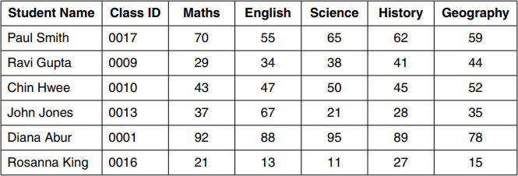

- State which field you would choose for the primary key.
...............................................................................................................................
Give a reason for choosing this field.
...............................................................................................................................
...............................................................................................................................
- The query-by-example grid below selects all students with more than 60 marks in History or more than 60 marks in Geography
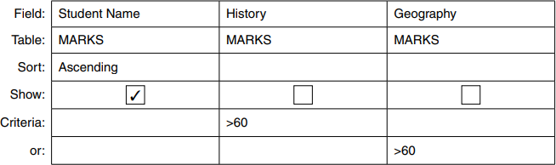

Show what would be output.
...............................................................................................................................
...............................................................................................................................

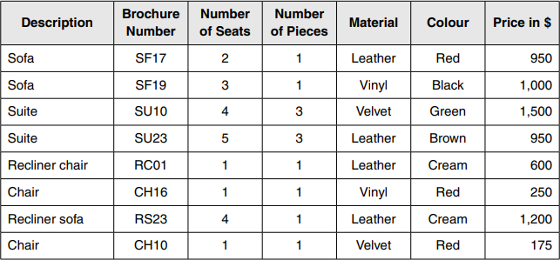
- A database, SOFASELECT, was set up to show the prices of suites, sofas and chairs for sale from an online furniture warehouse. Part of the database is shown below

- State the data type you would choose for each of the following fields.
Number of Seats......................................................................................................
Price in $ .................................................................................................................

- The query-by-example grid below selects all the furniture in cream leather.
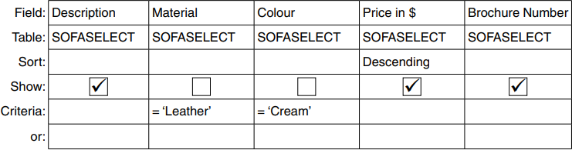

Show the output from the query-by-example.
............................................................................................................................. .......
....................................................................................................................................

- Complete the query-by-example grid below to select and show the brochure number, material, colour and price of all the furniture with 3 or more seats.
Field:
Table:
Sort:
Show:

Criteria:
or:

- A motor car manufacturer offers various combinations of:
» seat colours
» seat materials
» car paint colours.
A table, CAR, was set up as single-table database to help customers choose which seat and paint combinations were possible. (NOTE: N = no, not a possible combination, Y = yes, combination is possible)
Code | Cloth | Leather | Seat Colour | White | Red | Black | Blue | Green | Silver | Grey
CB | Y | N | black | Y | Y | Y | Y | Y | Y | Y
LB | N | Y | black | N | Y | N | N | N | Y | Y
CC | Y | N | cream | N | Y | Y | Y | N | N | N
LC | N | Y | cream | N | Y | Y | Y | N | N | Y
CG | Y | N | grey | N | Y | Y | Y | Y | Y | N
LG | N | Y | grey | N | Y | N | Y | N | Y | Y
CR | Y | N | red | Y | N | Y | N | N | Y | Y
LR | N | Y | red | Y | N | Y | N | N | Y | Y
CB | Y | N | blue | N | N | N | Y | N | N | N
LB | N | Y | blue | N | N | Y | Y | Y | N | N

- State the number of records shown in the table.
…………………………………………………………………………………
…………………………………………………………….
- State the number of fields shown in the table.
............................................................................................................................. ..
State, with a reason, if any of the fields are suitable to use as primary key.
...............................................................................................................................
............................................................................................................................. .

- The following SQL command was used:
SELECT Code FROM CAR
WHERE SeatColour = 'Red' AND ('White' OR 'silver');
Show what will be displayed.
............................................................................................................................. ..
............................................................................................................................. .

- A customer wanted to know all the possible combinations for a car with leather seats and either silver or grey paint colour. Complete the SQL command required.
SELECT *
FROM .......................................
WHERE .................. leather AND (silver grey);

- A database table, TRAIN, is to be set up for a railway company to keep a record of the engines available for use. Each engine has a unique number made up of 5 digits, nnnnn. The engines are classified as freight (F) or passenger (P) together with a power classification that is a whole number between 0 and 9, for example F8. The railway company keeps a record of the date of the last service for each engine.
- Identify the three fields required for the database. Give each field a suitable name and data type. Provide a sample of data that you could expect to see in the field.
Field 1 Name
............................................................................................................................
Data type
...............................................................................................................................
Data sample
.............................................................................................................................

Field 2 Name
............................................................................................................................
Data type
...............................................................................................................................
Data sample
.............................................................................................................................

Field 3 Name
............................................................................................................................
Data type
...............................................................................................................................
Data sample
.............................................................................................................................

- State the field that you should choose as the primary key.
............................................................................................................................. ..

- A database table, SHEEP, is used to keep a record of the sheep on a farm. Each sheep has a unique ear tag, EARnnnn; n is a single digit. The farmer keeps a record of the date of birth, the gender and the current weight of each sheep in kilograms.
- State the field that you would choose as the primary key.
............................................................................................................................. ..

- Using the query-by-example grid below, write a query to identify the ear tags of all male sheep weighing over 10 kilograms. Only display the ear tags.
Field:
Table:
Sort:
Show:
Criteria:
or:

- A company that sells bicycles keeps records of the items in stock in a table, CYCLE, using a single-table database. For each model of bicycle, the following data is kept:
- model number, for example: BY00007
- description of model, for example: lady’s shopper
- colour of frame, for example: gold and black
- size of wheels, for example: 700 mm
- price of model in $, for example: $309.50
- still being manufactured: Yes or No
- number in stock.

- Identify, with a reason for each, the validation required for each of these fields:
  - model number
..........................................................................................................................

  - price
...........................................................................................................................

  - number in stock.
...........................................................................................................................

- State, with a reason, the field that would be suitable to use as primary key.
...............................................................................................................................
...............................................................................................................................

- A database table, TREES, is used to keep a record of the trees in a park. Each tree is given a unique number and is examined to see if it is at risk of dying. There are over 900 trees; part of the database table is shown.
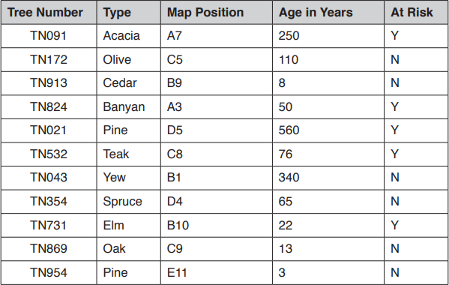

- The tree numbering system uses TN followed by three digits. The numbering system will not work if there are over 1000 trees.
Describe, with the aid of an example, how you could change the tree numbering system to allow for over 1000 trees.
Existing tree numbers must not be changed.
....................................................................................................................................
............................................................................................................................. .......
....................................................................................................................................
............................................................................................................................. .......

- Using the query-by-example grid, write a query to identify at risk trees over 100 years old. Display only the type and the position on the map.

Field:
Table:
Sort:
Show:
Criteria:
or:

- A database table, PORTRAIT, is used to keep a record of the portraits available from a photographic studio. Each portrait has a unique reference number PICnnn, where n is a single digit, for example PIC123. The studio keeps a record of the size (for example 20 × 15), the type (black and white or colour), and the price in dollars.
- Complete the table to show the most appropriate data type for each of the fields.
Field | Data type
Reference number
Size
Type
Price in $

- The results from the query-by-example grid should show the reference number, price, type and size of all portraits under $50. Identify the three errors in the query-by-example grid.
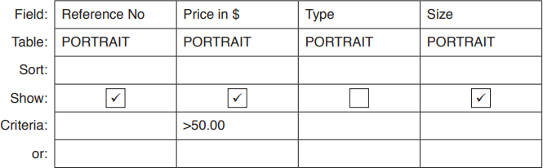

Error 1
............................................................................................................................. ..
...............................................................................................................................
Error 2

............................................................................................................................. ..
...............................................................................................................................
Error 3
............................................................................................................................. ..
...............................................................................................................................

- A database table, PERFORMANCE, is used to keep a record of the performances at a local theatre.
Show Number | Type | Title | Date | Sold Out
SN091 | Comedy | An Evening at Home | 01-Sep | Yes
SN102 | Drama | Old Places | 02-Oct | No
SN113 | Jazz | Acoustic Evening | 03-Nov | No
SN124 | Classical | Mozart Evening | 04-Dec | Yes
SN021 | Classical | Bach Favourites | 01-Feb | Yes
SN032 | Jazz | 30 Years of Jazz | 02-Mar | Yes
SN043 | Comedy | Street Night | 03-Apr | No
SN054 | Comedy | Hoot | 04-May | No

- State the number of fields and records in the table.
Fields ......................................................................................................
Records ...................................................................................................

- Give two validation checks that could be performed on the Show Number field.
Validation check 1
..............................................................................................................................
............................................................................................................................. ..
Validation check 2 ...............................................................................................
............................................................................................................................. ..

- A database table, FLIGHT, is used to keep a record of flights from a small airfield. Planes can carry passengers, freight or both. Some flights are marked as private and only carry passengers.
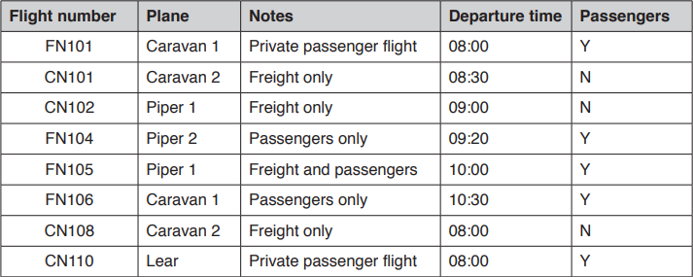

- State the field that could have a Boolean data type. Field
...............................................................................................................................

- A query-by-example has been written to display just the flight numbers of all planes leaving after 10:00 that only carry passengers.
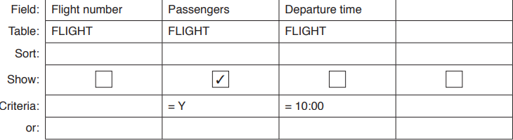

Explain why the query-by-example is incorrect, and write a correct query-by-example.
Explanation
....................................................................................................................................
....................................................................................................................................
....................................................................................................................................
....................................................................................................................................
....................................................................................................................................
Field:
Table:

Sort:
Show:
Criteria:
or:

- A database table, SALES, is used to keep a record of items made and sold by a furniture maker.
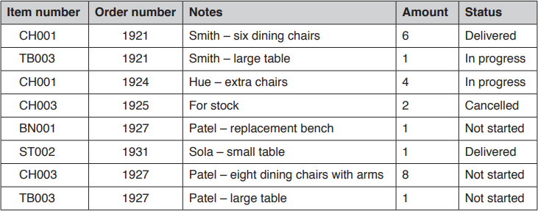

- Explain why the field Item number could not be used as a primary key.
............................................................................................................................. ..
...............................................................................................................................

- A query-by-example has been written to display only the order number and item numbers of any items in progress or not started.
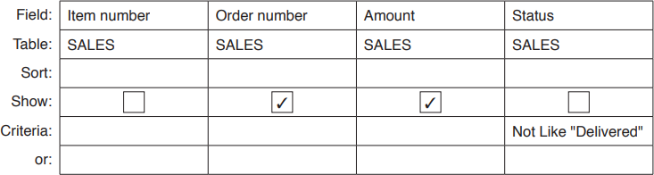

Explain why the query-by-example is incorrect, and write a correct query-by-example. Explanation
...............................................................................................................................
............................................................................................................................. ..
...............................................................................................................................

............................................................................................................................. ..
...............................................................................................................................
Field:
Table:
Sort:
Show:
Criteria:
or:

- A database table, CapitalCity, stores data about capital cities from around the world.
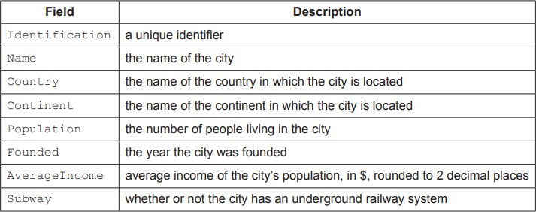
- Complete the table by writing one appropriate field from CapitalCity for each data type.
Each field must be different.
Data type | Field
Boolean
Integer
Real
Text

- Complete the structured query language (SQL) statement to list only the name, country and population of all the cities in CapitalCity from the continent of Asia. SELECT
....................................................................................................................................
. CapitalCity
WHERE =
. ;

